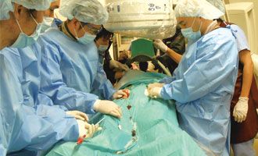
Date: 13th December, 2016

Venue: Lecture Theatre, M/F, Hospital Authority Building 147B Argyle Street Kowloon

All Are Welcome, No Registration Required
CME Hong Kong College of Physicians 1 point
CME Hong Kong College of Anaesthesiologists 2 points
CNE Pending

Enquiry:

Dr. Arthur MC Kwan kmc8041@pmh.ha.org.hk/64610082

Academic Sharing Meeting

ECMO Workgroup, COC (ICU)

Difficult Moments in ECMO practice

1800-1830 Registration
1830-1900 Experience from QEH
1900-1930 Experience from PMH
1930-2000 Experience from PYNEH
2000-2030 Experience from PWH

112
1

