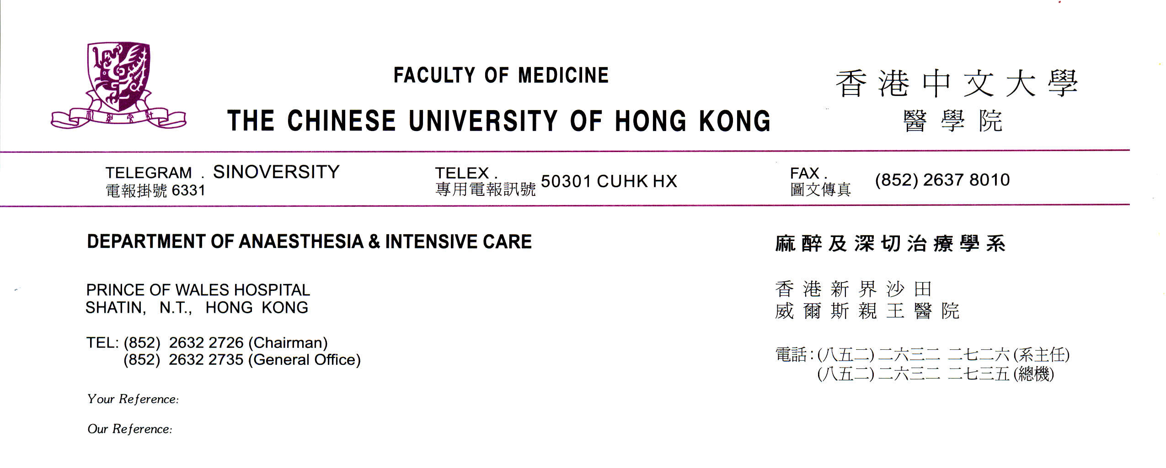

BASIC For Nurses course

REGISTRATION FORM

To register please complete the following details and pay by bank draft or cheque, made payable to “The Chinese University of Hong Kong” (payee name must include “The”).

Course Date: | 14th – 15th July 2014
Surname:

Given name:

Corresponding address:

Email address:

Department:

Hospital:

Please post this form and your bank draft or cheque of HK$1,500 to:

Rebecca LUK
Dept of Anaesthesia & Intensive Care
Prince of Wales Hospital
Shatin, Hong Kong

Tel: 2632 2087
Email: rebeccaluk@cuhk.edu.hk

(For course information and enquiry, please contact Miss Carmen HO at carmenho@aic.cuhk.edu.hk or 2632-3028)

The deadline for registration is 29th June 2014

